**Shirove Communicator**

Shirove is an assistive on-screen keyboard which runs on Windows. It is designed to be used with a low cost eye-tracking device to bring keyboard control, mouse control and speech to people with motor and speech limitations, such as people living with Amyotrophic Later Sclerosis (ALS) / Motor Neuron Disease (MND).

It works out of the box once you have your eye-tracking device installed and allows selections to be made using dwell selection, as well as physical buttons and assistive devices (such as Glassouse, or assistive switches). If you do not have an eye tracking device you can use Shirove with a mouse or your webcam.

Shirove can be used as an alternative to a physical keyboard, allowing you to type into any application. Shirove can automatically insert spaces between words and capitalise letters for you to increase your typing rate. You can even type whole words and phrases in a single selection by "swiping" or using "auto-complete".

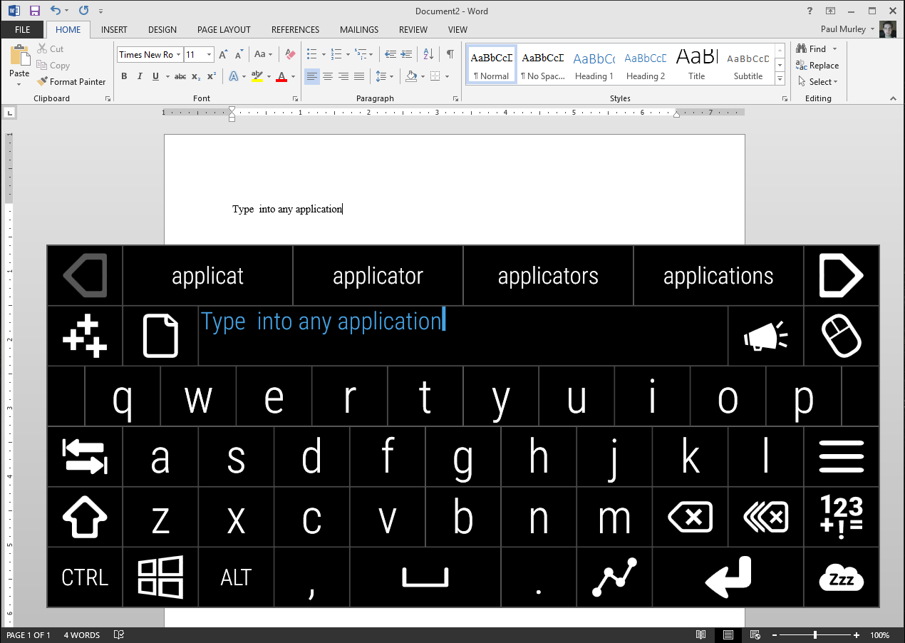

Shirove can replace your mouse, allowing you to click, scroll and drag with precision anywhere on screen.

To communicate naturally with those around you select the 'Speak' key and Shirove will convert what you have typed into speech...even if you find it difficult to select keys...

Shirove can be controlled with a mouse, or an eye tracker (the preferred method), but it is also possible to use a standard webcam. There are a number of free applications which can use your webcam to track your head movements and translate those into movements of your mouse cursor on screen. As Shirove can be controlled using the cursor position this means you can control Shirove using head movements captured via your webcam. This method is a very different experience from using an eye tracking device, but can be very effective.

These applications should all work with Shirove:

* [Enable Viacam](http://eviacam.sourceforge.net/index.php) - free and open source
* [Camera Mouse](http://www.cameramouse.org/) - free
* [Open Gazer](http://www.inference.phy.cam.ac.uk/opengazer/) - free and open source